

Insyde PlatformInfo Technical Reference

Revision 1.7
Nov. 2023


Copyright (c) 2023, All Rights Reserved. Insyde Software.
No part of this publication may be reproduced, transmitted, transcribed, stored in a retrieval system, or translated into any language or computer language, in any form, or by any means, electronic, mechanical, magnetic, optical, chemical, manual or otherwise, without the prior written permission of Insyde Software Corp.

Disclaimer
Insyde Software provides this document and the programs "as is" without warranty of any kind, either expressed or implied, including, but not limited to, the implied warranties of merchantability or fitness for a particular purpose.
This document could contain technical inaccuracies or typographical errors. Changes are periodically made to the information herein; these changes will be incorporated in future revisions of this document. Insyde Software is under no obligation to notify any person of the changes.
The following trademarks are used in this document:
Insyde and InsydeH2O are registered trademarks or trademarks of Insyde Software. All other trademarks or trade names are property of their respective holders.
Contents
目錄
Disclaimer 2
1 Introduction 8
1.1 Overview 8
1.2 Related Information 8
2 Platform Info Overview 9
2.1 Main Feature 9
2.1.1 Setup Menu 9
2.1.1.1 Memory 9
2.1.1.2 CPU 10
2.1.1.3 SATA 11
2.1.1.4 NVME 14
2.1.1.5 SD/eMMC 16
2.1.1.6 PCIe 20
2.1.1.7 USB 23
2.1.2 Post Menu 25
2.2 Folder Construction 26
3 PCDs Description 32
3.1 PcdsFeatureFlag 32
3.1.1 PcdH2OplatformInfoSupported 32
3.1.2 PcdH2OMemoryDeviceInfoSupported 32
3.1.3 PcdH2OPciLookupTableSupported 32
3.1.4 PcdH2OCpuDeviceInfoSupported 32
3.1.5 PcdH2OSataDriveInfoSupported 32
3.1.6 PcdH2OUsbTextLookupSupported 32
3.1.7 PcdH2OPciSkipTableSupported 33
3.1.8 PcdH2ONvmeInfoSupported 33
3.1.9 PcdH2OSDEmmcInfoSupported 33
3.1.10 PcdH2OConsoleBootMessageSupported 33
3.1.11 PcdH2OPciDeviceInfoSupported 33
3.1.12 PcdH2OSetupNvmeInfoSupported 33
3.1.13 PcdH2OSetupMemoryInfoSupported 33
3.1.14 PcdH2OSetupPciDeviceInfoSupported 33
3.1.15 PcdH2OSetupCpuInfoSupported 33
3.1.16 PcdH2OSetupSataDriveInfoSupported 34
3.1.17 PcdH2OSetupUsbViewerSupported 34
3.1.18 PcdH2OSetupSDEmmcInfoSupported 34
3.1.19 PcdH2OPciLookUpVendorIdTableSupported 34
3.1.20 PcdH2OPciLookUpDeviceIdTableSupported 34
3.1.21 PcdH2OPciLookUpClassCodeTableSupported 34
3.1.22 PcdH2OPciLookUpCapabilityIdTableSupported 34
3.1.23 PcdH2OpciLookUpCapabilityIntnTableSupported 34
3.2 PcdsFixedAtBuild 34
3.2.1 PcdH2ONvmeInfoLinkToFormsetGuid 34
3.2.2 PcdH2OMemoryInfoLinkToFormsetGuid 34
3.2.3 PcdH2OPciDeviceInfoLinkToFormsetGuid 35
3.2.4 PcdH2OCpuInfoLinkToFormsetGuid 35
3.2.5 PcdH2OSataDriveInfoLinkToFormsetGuid 35
3.2.6 PcdH2OUsbViewerLinkToFormsetGuid 35
3.2.7 PcdH2OSDEmmcInfoLinkToFormsetGuid 35
3.2.8 PcdH2OMemoryDetailDisplayList 35
3.2.9 PcdH2OCpuDetailDisplayList 35
3.2.10 PcdH2OSDEmmcDetailDisplayList 35
3.2.11 PcdH2OHiddenNotInstalledMemory 35
3.2.12 PcdH2ODeviceInfoAttributeStr 35
3.2.13 PcdH2OPciSkipDeviceTable 36
3.2.14 PcdH2OIntelMsrRaplPwrUnitAddress 36
3.2.15 PcdH2OIntelMsrPkgPwrLimitAddress 36
3.2.16 PcdH2OAmdBiosSmcMsgTdpRequestId 36
3.2.17 PcdH2OAmdMp1C2pmsgMessageAddress 36
3.2.18 PcdH2OAmdMp1C2pmsgResponseAddress 36
3.2.19 PcdH2OAmdMp1C2pmsgArgument0Address 36
3.2.20 PcdH2OAmdMp1C2pmsgArgument1Address 36
3.2.21 PcdH2OAmdMp1C2pmsgArgument2Address 36
3.2.22 PcdH2OAmdMp1C2pmsgArgument3Address 36
3.2.23 PcdH2OAmdMp1C2pmsgArgument4Address 36
3.2.24 PcdH2OAmdMp1C2pmsgArgument5Address 37
3.2.25 PcdH2OBmcInfoDisplayNameForChannel 37
3.2.26 PcdH2OUsbViewerFormRefreshPeriod 37
3.2.27 PcdH2OConsoleBootMessageMarginBottom 37
3.2.28 PcdH2OConsoleBootMessageMarginRight 37
3.2.29 PcdH2OpciCapabilityDisplayControl 37
4 Customization Instructions 38
4.1 Setup Menu Link 38
4.2 Memory/CPU/SD,eMMC Info Setup Submenu Display 38
4.3 PCIe Info Setup Menu Display 39
4.4 Unit Format Display In Setup Menu 40
4.5 Post Info Display 40
4.6 Insyde DeviceInfo in PlatformInfo 41
4.7 BMC Lan Display 42
4.8 PCI Capability ID Display 43

Figures
Figure 1: Memory Info Setup Main Menu 9
Figure 2: Memory Info Setup Submenu 10
Figure 3: CPU Info Setup Menu 11
Figure 4: SATA Driver Info Setup Main Menu (Controller Mode) 12
Figure 5: SATA Drive Info Setup Main Menu (Physical Port Mode) 13
Figure 6: SATA Driver Info Setup Submenu 14
Figure 7: NVME Info Setup Main Menu 15
Figure 8: NVME Info Setup Submenu 16
Figure 9: SD/eMMC Setup Main Menu (By Types) 17
Figure 10: SD/eMMC Setup Main Menu (By Ports) 18
Figure 11: SD/eMMC Setup Submenu (eMMC) 19
Figure 12: SD/eMMC Setup Submenu (SD Card) 20
Figure 13: PCI Info Setup Main Menu 21
Figure 14: PCI Info Setup Submenu (Capability Interpretation Disabled) 22
Figure 15: PCI Info Setup Submenu (Capability Interpretation Enabled) 23
Figure 16: USB Info Setup Main Menu 24
Figure 17: USB Info Setup Submenu 25
Figure 18: Post Info 26

Tables
Table 1: Folder Description 25
Table 2: Insyde Common Formset GUID List 37
Table 3: Submeu List Define 38
Table 4: Setup Menu Format Description 39
Table 5: Post Info Format Description 39
Table 6: the customized modification parameters 41

Revision History

Revision  Number | Description | Author | Release  Date
<1.0> | Initial release. | Ryan Chang | May, 2022
<1.1> | - Update Folder Construction  - Add 3.2.29 PcdH2OPcieLookUpVendorTableSupported  - Add 3.2.30 PcdH2OPcieLookUpDeviceTableSupported | Ryan Chang | May, 2022
<1.2> | - Update Folder Construction  - Add 3.1.11 PcdH2OPciDeviceInfoSupported  - Update 3.1.14 PcdH2OSetupPcieDeviceInfoSupported to PcdH2OSetupPciDeviceInfoSupported  - Add 3.1.19 PcdH2OPciLookUpVendorIdTableSupported  - Add 3.1.20 PcdH2OPciLookUpDeviceIdTableSupported  - Add 3.1.21 PcdH2OPciLookUpClassCodeTableSupported  - Add 3.1.22 PcdH2OPciLookUpCapabilityIdTableSupported  - Update 3.2.3 PcdH2OPcieInfoLinkToFormsetGuid to PcdH2OPciDeviceInfoLinkToFormsetGuid  - Remove 3.2.29 & 3.2.30 | Ryan Chang | Sept, 2022
<1.3> | - Update Figure.4 photo for new display layout | Ryan Chang | Sept, 2022
<1.4> | - Update Figure 13 photo for new display layout (Locate Slot -> Slot Name) | Ryan Chang | Otc, 2022
<1.5> | - Update Figure 16 photo for new display layout  - Update 3.2.24 PcdH2OBmcInfoDisplayIpAddressEn to PcdH2OBmcInfoDisplayNameForChannel  - Add 4.7 BMC Lan Display | Ryan Chang | Jan. 2023
<1.6> | - Add 3.1.23 PcdH2OPciLookUpCapabilityIntnTableSupported  - Add 3.2.29 PcdH2OpciCapabilityDisplayControl  - Update PCI Info Figure photo  - Add 4.8 PCI Capability ID Display | Ryan Chang | Mar. 2023
<1.7> | - Add eMMC & SD sample in 4.6 Insyde DeviceInfo in PlatformInfo  - Update photo in 2.1.1.5 SD/eMMC  - Add photo for NVME with Intel VMD | Ryan Chang | Nov. 2023

Introduction
This document is a part of the InsydePlatformInfo Technical Reference, which describes the architectural features of the product. These architectural features serve as an agreement between Insyde and its partners and customers about the types of APIs, data structures, processes and file formats that the InsydeH2O product will use and produce.

Overview
This document introduces the functions included in InsydePlatformInfo (Memory/CPU/SATA/NVME/SD, eMMC/PCI List/USB List Setup display and BIOS Post information) and how to control through PCDs, customize functions, etc..

Related Information
The following publications and sources of information are referred to by this document or may be useful to you:
- InsydeH2O Setup Technical Reference
- InsydeH2O BDS Technical Reference
- InsydeH2O Build Technical Reference

Platform Info Overview

Main Feature

Setup Menu

Memory
The memory information will list all the slots and show whether there is any device connected to the slot and the current total memory size of the system. In addition, you can also choose to hide the slots that are not connected to the memory.
When entering the respective memory page, detailed information will be displayed. For example, Memory Type/Serial Number/Part Number/Configured Memory Speed etc..
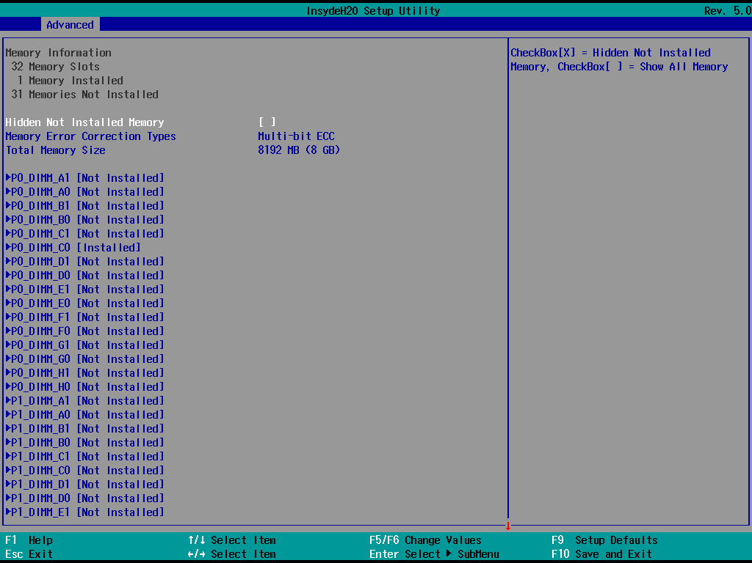
Figure 1: Memory Info Setup Main Menu
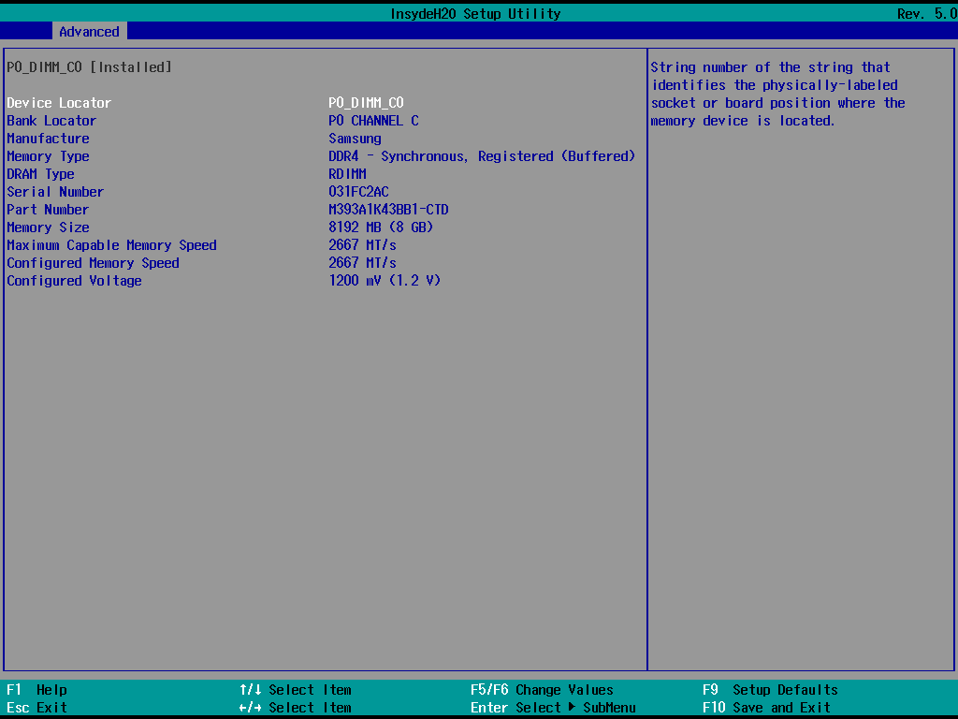
Figure 2: Memory Info Setup Submenu

CPU
The CPU information will display the common content of all CPUs in the current system, such as Process Type/Speed/CPU ID/Number of processors, etc..
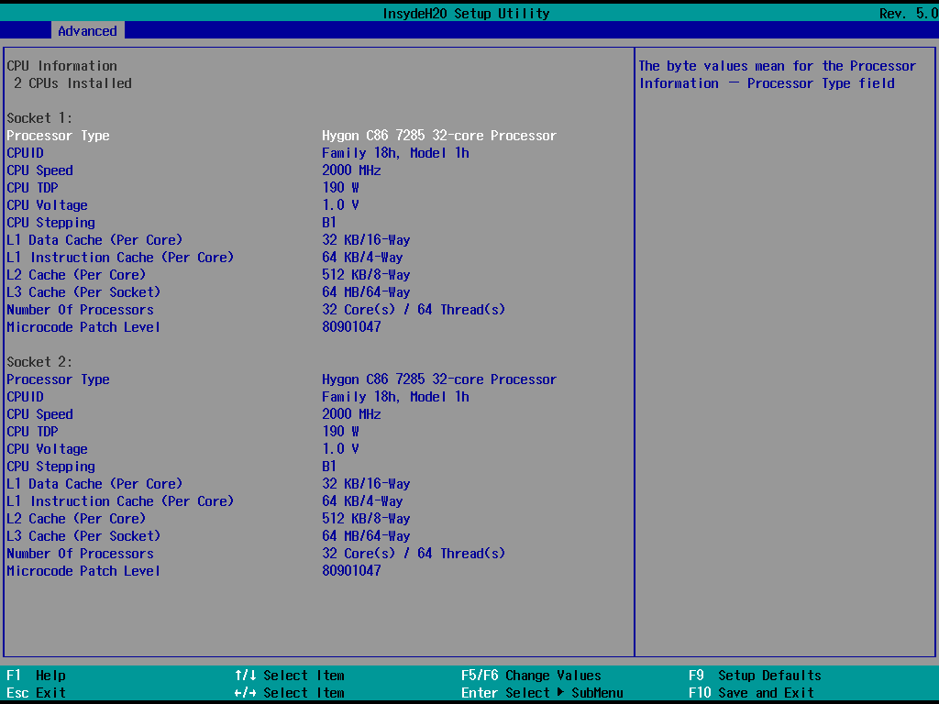
Figure 3: CPU Info Setup Menu

SATA
The SATA information will list the port connection status of all controllers and the total number of SATA drivers connected to the platform. In addition, you can also choose to hide the ports that are not connected to the SATA Driver and only display the expected ports according to the customized results

When entering the respective SATA Driver page, detailed information will be displayed. For example: Capacity/Form factor/Rotation Rate/S.M.A.R.T Info etc..
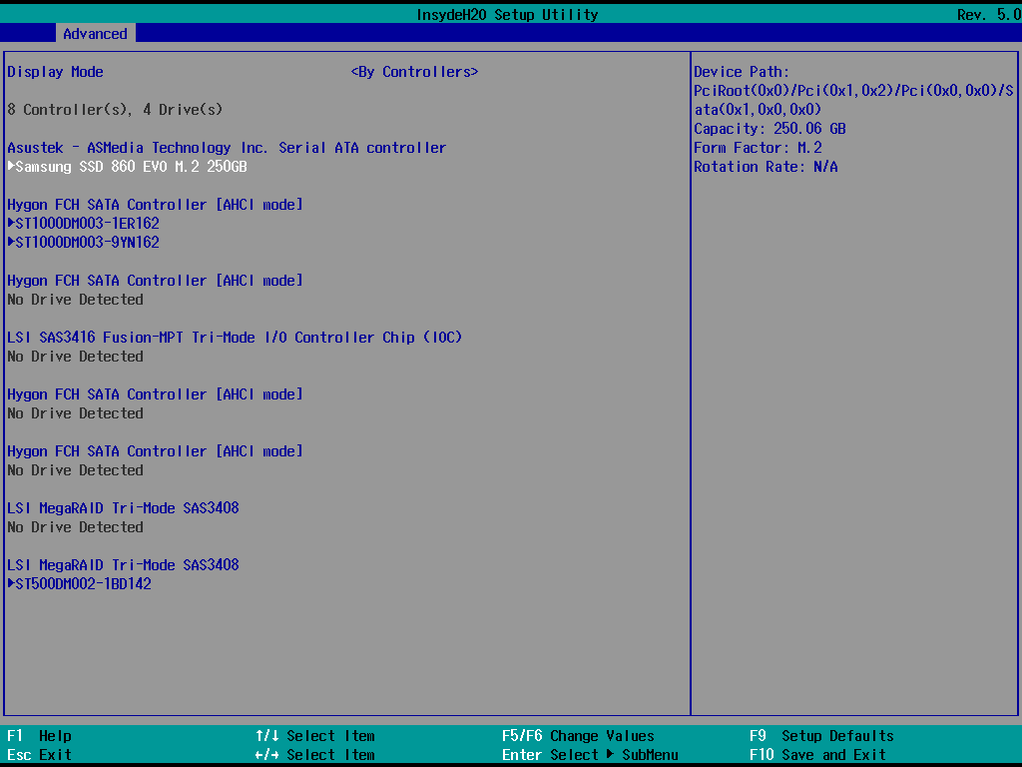
Figure 4: SATA Driver Info Setup Main Menu (Controller Mode)
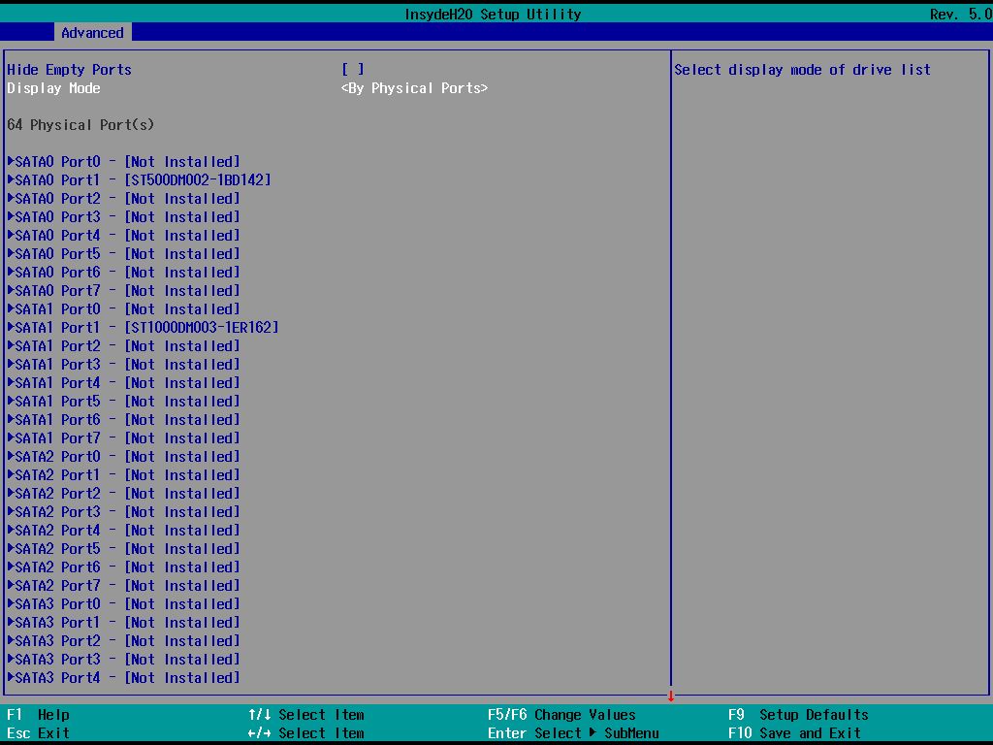
Figure 5: SATA Drive Info Setup Main Menu (Physical Port Mode)
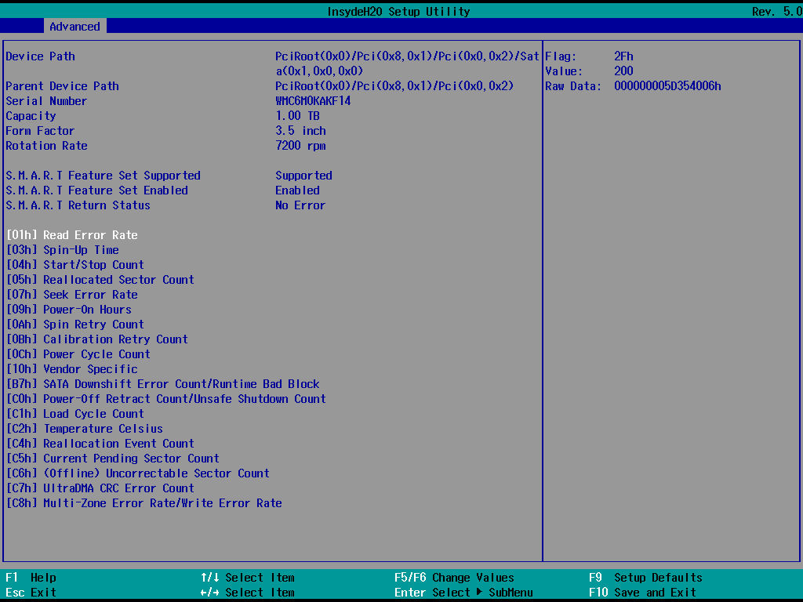
Figure 6: SATA Driver Info Setup Submenu

NVME
The NVME information will list all connected NVME devices and the desired slot and current connection status through customization.

When entering the respective NVME device page, detailed information will be displayed. For example: Capacity/Serial Number/Model Number/S.M.A.R.T Info etc..
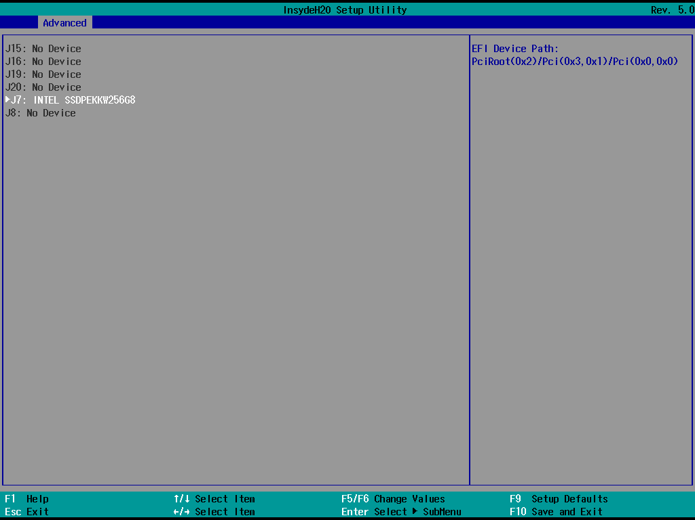
Figure 7: NVME Info Setup Main Menu
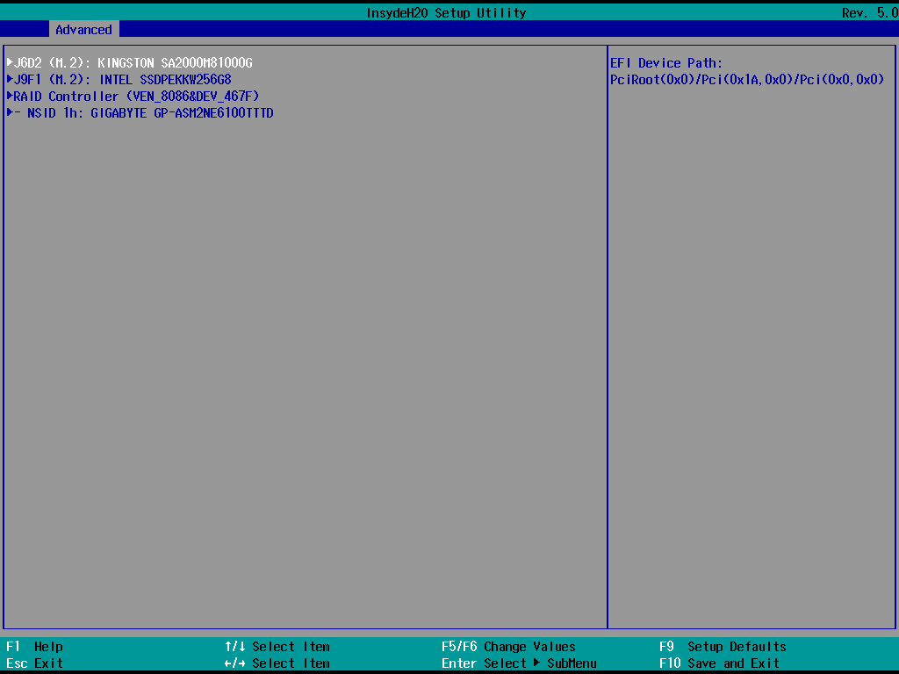
Figure 8: NVME Info Setup Main Menu (Support Intel VMD)
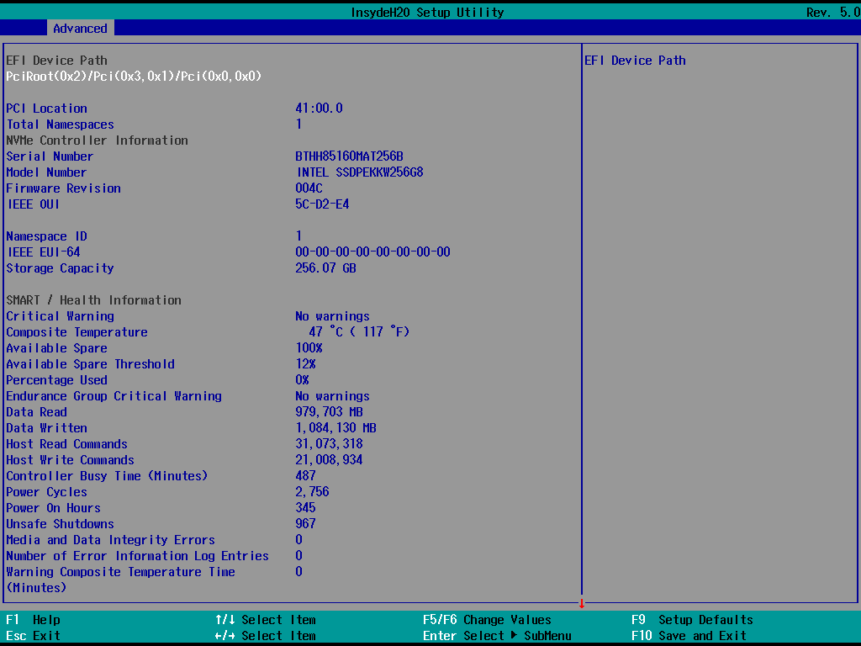
Figure 9: NVME Info Setup Submenu

SD/eMMC
The SD/eMMC information will list all connected SD/eMMC devices and the desired slot and current connection status through customization
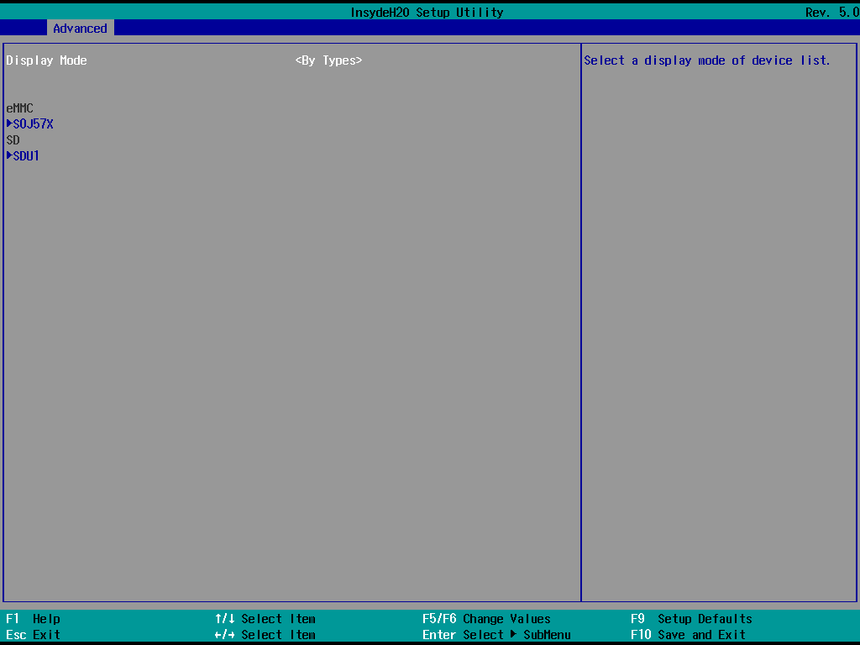
Figure 10: SD/eMMC Setup Main Menu (By Types)
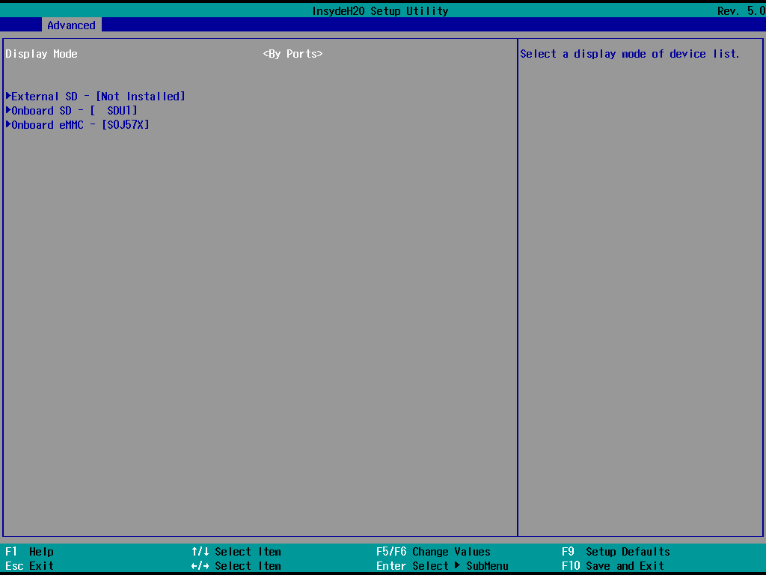
Figure 11: SD/eMMC Setup Main Menu (By Ports)
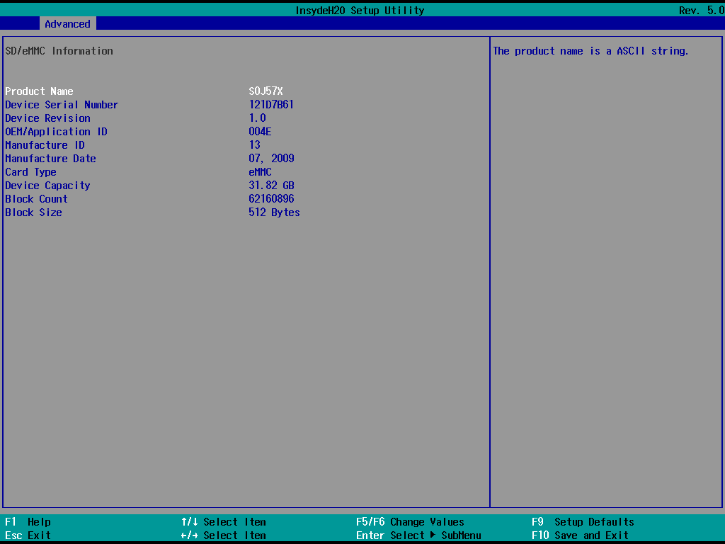
Figure 12: SD/eMMC Setup Submenu (eMMC)
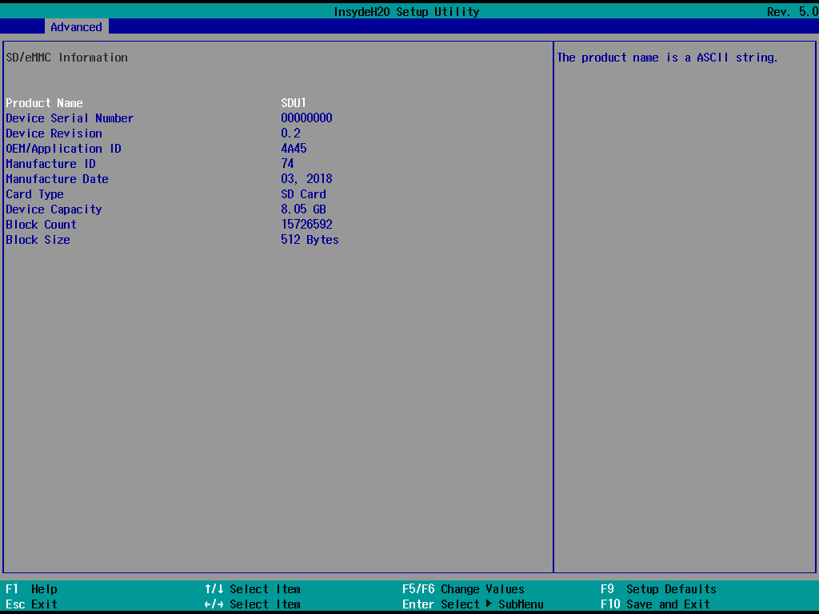
Figure 13: SD/eMMC Setup Submenu (SD Card)

PCIe
The PCI information will list all PCI/PCIe devices and also include the resolution database of the corresponding device name for easy understanding. In addition, the display mode can be changed through Show Actual Device Name/Show Device Tree/Filtering Mode.

When entering the respective PCI device, detailed information will be displayed. For example: Vendor ID/Device ID/Location(Bus, Device, Function)/Class Code etc..
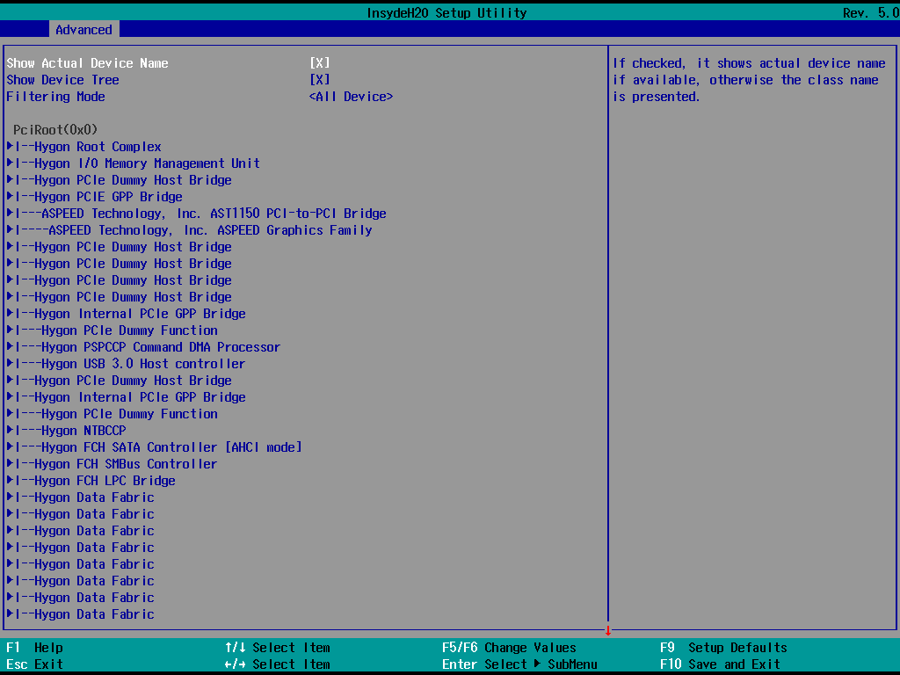
Figure 14: PCI Info Setup Main Menu
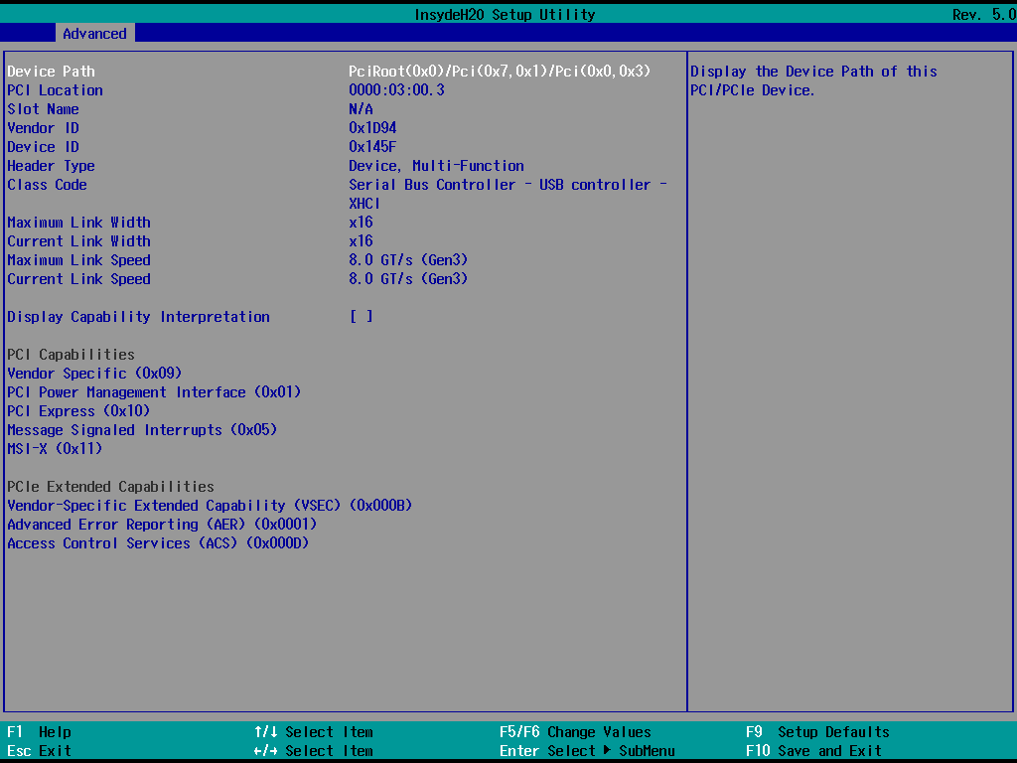
Figure 15: PCI Info Setup Submenu (Capability Interpretation Disabled)
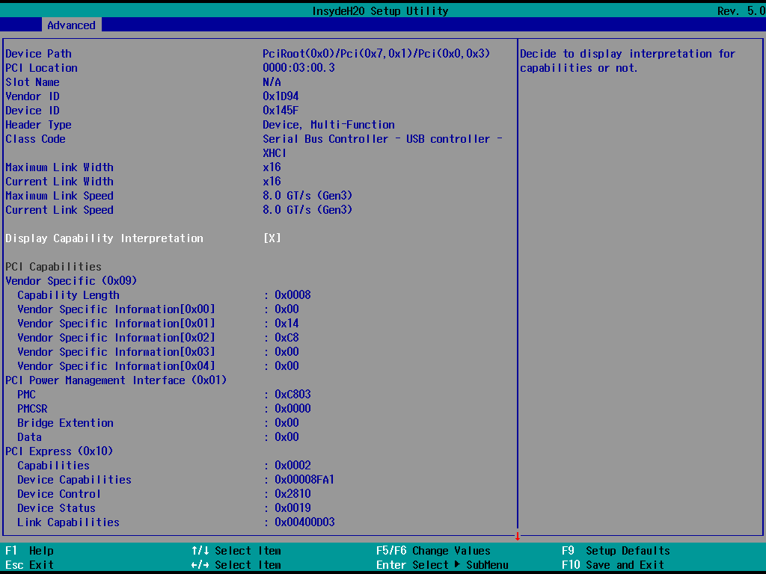
Figure 16: PCI Info Setup Submenu (Capability Interpretation Enabled)

USB
The USB message will list all controllers and connected USB devices. In addition, you can switch whether to display in a tree view through Flat View.

When entering the respective USB device page, detailed information will be displayed. For example: Interface description/capacity etc..
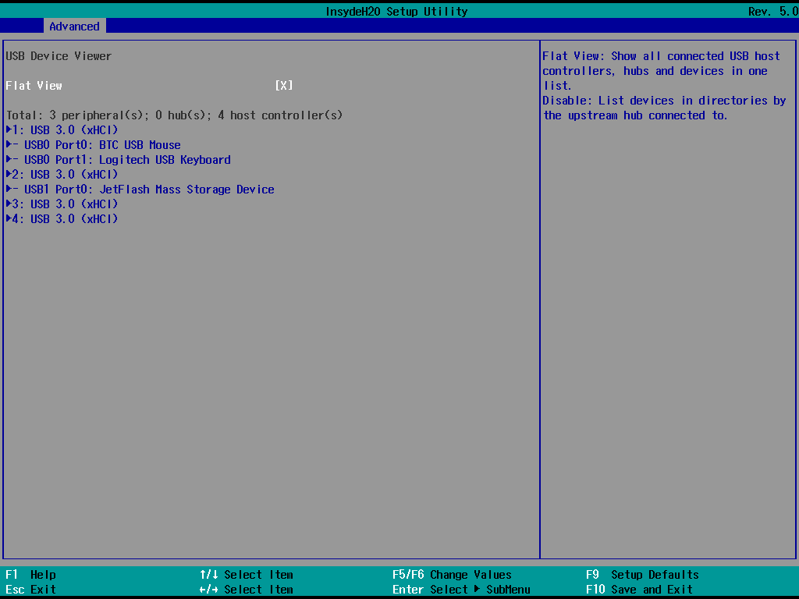
Figure 17: USB Info Setup Main Menu
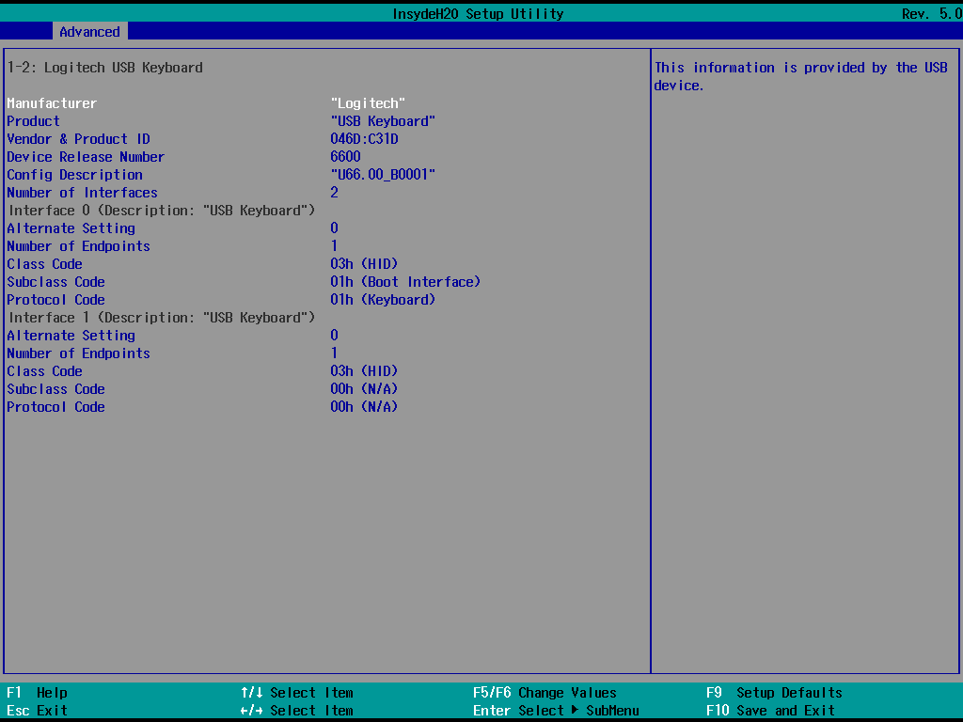
Figure 18: USB Info Setup Submenu

Post Menu
When Quiet Mode is turned off in Setup Menu, the Post process will be displayed in text mode. PlatformInfo provides simplified display related information at this stage. For example: CPU/Memory/BMC/SATA/NVME etc..
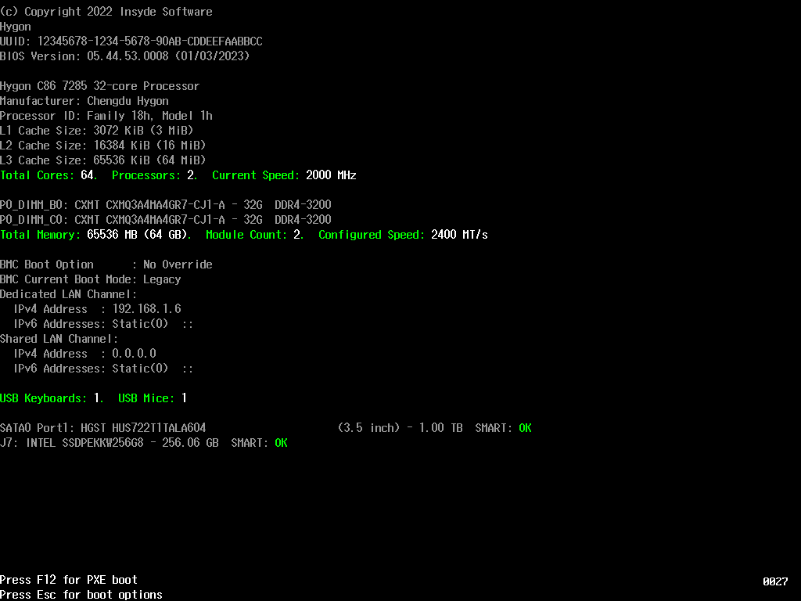
Figure 19: Post Info

Folder Construction
Table 1: Folder Description
Function Description | File
PCDs function definition, Driver description | InsydePlatformInfoPkg.dec  InsydePlatformInfoPkg.ifc  Package.dsc  Package.fdf
Memory information collection and parsing interface  (DXE Protocol) | MemoryDeviceInfoDxe\  MemoryDeviceInfoDxe.c  MemoryDeviceInfoDxe.h  MemoryDeviceInfoDxe.inf  MemoryDeviceInfoString.uni
Memory setup menu driver | MemoryInfoSetupUtilityDxe\  MemoryDetailDisplay.c  MemoryInfoFormset.h  MemoryInfoSetupUtilityDxe.c  MemoryInfoSetupUtilityDxe.h  MemoryInfoSetupUtilityDxe.inf  MemoryInfoStr.uni  MemoryInfoVfr.vfr
CPU information collection and parsing interface  (DXE Protocol) | CpuDeviceInfoDxe\  CpuDeviceInfoDxe.c  CpuDeviceInfoDxe.h  CpuDeviceInfoDxe.inf
CPU setup menu driver | CpuInfoSetupUtilityDxe\  CpuDetailDisplay.c  CpuInfoFormset.h  CpuInfoSetupUtilityDxe.c  CpuInfoSetupUtilityDxe.h  CpuInfoSetupUtilityDxe.inf  CpuInfoVfr.uni  CpuInfoVfr.vfr
SATA information collection and parsing interface  (DXE Protocol) | SataDriveInfoDxe\  AtaCommands.c  AtaCommands.h  SataDriveInfoDxe.c  SataDriveInfoDxe.h  SataDriveInfoDxe.inf
SATA setup menu driver | SataDriveInfoSetupUtilityDxe\  SataDriveInfoSetupNVDataStruc.h  SataDriveInfoSetupUtilityDxe.c  SataDriveInfoSetupUtilityDxe.h  SataDriveInfoSetupUtilityDxe.inf  SataDriveInfoSetupUtilityDxe.uni  SataDriveInfoVfr.vfr
NVME information collection and parsing interface  (DXE Protocol) | NvmeInfoDxe\  NvmeInfoDxe.c  NvmeInfoDxe.inf
NVME setup menu driver | NvmeInfoSetupUtilityDxe\  NvmeInfoFormset.h  NvmeInfoSetupUtilityDxe.c  NvmeInfoSetupUtilityDxe.h  NvmeInfoSetupUtilityDxe.inf  NvmeInfoStr.uni  NvmeInfoVfr.vfr  NvmeSmartInfo.c  NvmeSmartInfoString.uni
SD/eMMC information collection and parsing interface  (DXE Protocol) | SDEmmcInfoDxe\  SDEmmcInfoDxe.c  SDEmmcInfoDxe.h  SDEmmcInfoDxe.inf
SD/eMMC setup menu driver | SDEmmcInfoSetupUtilityDxe\  SDEmmcInfoFormPolicy.h  SDEmmcInfoSetupUtilityDxe.c  SDEmmcInfoSetupUtilityDxe.h  SDEmmcInfoSetupUtilityDxe.inf  SDEmmcInfoSetupUtilityDxe.uni  SDEmmcInfoSetupUtilityDxevfr.vfr
PCI information conversion table and interface  (DXE Protocol) | PciLookupDxe\  PciCommonStr.uni  PciLookupDxe.c  PciLookupDxe.h  PciLookupDxe.inf
PCI information collection and parsing interface  (DXE Protocol) | PciDeviceInfoDxe\  PciDeviceInfoDxe.c  PciDeviceInfoDxe.h  PciDeviceInfoDxe.inf
PCI setup menu driver | PciDeviceInfoSetupUtilityDxe\  PciDeviceInfoSetupNVDataStruc.h  PciDeviceInfoSetupUtilityDxe.c  PciDeviceInfoSetupUtilityDxe.h  PciDeviceInfoSetupUtilityDxe.inf  PciDeviceInfoSetupUtilityDxe.uni  PciDeviceInfoVfr.vfr
USB class code parsing interface  (DXE Protocol) | UsbTextLookupDxe\  H2OUsbClassCodeString.c  H2OUsbClassCodeString.h  H2OUsbClassCodeString.uni  UsbTextLookupDxe.c  UsbTextLookupDxe.h  UsbTextLookupDxe.inf  UsbTextLookupDxe.uni
USB setup menu driver | UsbViewerDxe\  HiiConfigAccess.c  UsbViewerDxe.c  UsbViewerDxe.h  UsbViewerDxe.inf  UsbViewerSetup.h  UsbViewerStr.uni  UsbViewerVfr.vfr
Post message handle interface  (DXE Protocol) | ConsoleBootMsgDxe\  ConsoleBootMsgDxe.c  ConsoleBootMsgDxe.h  ConsoleBootMsgDxe.inf  ConsoleBootMsgProtocol.c  ConsolePrintRoutines.c
Post message driver | PlatformInfoBootMsgDxe\  BasicSystemInfo.c  BmcInfo.c  BmcInfo.uni  CpuInfo.c  CpuInfo.uni  InputDeviceInfo.c  InputDeviceInfo.uni  MemoryInfo.c  MemoryInfo.uni  NvmeInfo.c  NvmeInfo.uni  PlatformInfoBootMsgDxe.c  PlatformInfoBootMsgDxe.h  PlatformInfoBootMsgDxe.inf  PlatformInfoBootMsgDxe.uni  SataDriveInfo.c  SataDriveInfo.uni  SdEmmcInfo.c  SdEmmcInfo.uni
Insyde deviceInfo collection and parsing interface  (DXE Protocol) | DeviceInfoLookupDxe\  DeviceInfoLookupDxe.c  DeviceInfoLookupDxe.h  DeviceInfoLookupDxe.inf  DisplayNameString.c  UsbPortLookup.c

PCDs Description

PcdsFeatureFlag

PcdH2OplatformInfoSupported
This is the main switch of PlatformInfo to control whether all functions can be enabled

PcdH2OMemoryDeviceInfoSupported
This item controls whether the memory information protocol is to be provided.
When this item is off it will disable the memory info setup menu even if PcdH2OSetupMemoryInfoSupported is on.

PcdH2OPciLookupTableSupported
This item controls whether the PCIe device database protocol is to be provided.
When this item is off it will disable the PCIe info setup menu even if PcdH2OSetupPcieInfoSupported is on.

PcdH2OCpuDeviceInfoSupported
This item controls whether the CPU information protocol is to be provided.
When this item is off it will disable the CPU info setup menu even if PcdH2OSetupCpuInfoSupported is on.

PcdH2OSataDriveInfoSupported
This item controls whether the SATA drive information protocol is to be provided.
When this item is off it will disable the SATA drive info setup menu even if PcdH2OSetupSataDriveInfoSupported is on.

PcdH2OUsbTextLookupSupported
This item controls whether the USB class code database protocol is to be provided.
When this item is off it will disable the USB info setup menu even if PcdH2OSetupUsbViewerSupported is on.

PcdH2OPciSkipTableSupported
This item is to control whether the PCIe info setup menu supports the function of hiding specific devices

PcdH2ONvmeInfoSupported
This item controls whether the NVME information protocol is to be provided.
When this item is off it will disable the NVME info setup menu even if PcdH2OSetupNvmeInfoSupported is on.

PcdH2OSDEmmcInfoSupported
This item controls whether the SD/eMMC information protocol is to be provided.
When this item is off it will disable the SD/eMMC info setup menu even if PcdH2OSetupSDEmmcInfoSupported is on.

PcdH2OConsoleBootMessageSupported
This item controls whether to enable the post information feature

PcdH2OPciDeviceInfoSupported
This item controls whether the PCI information protocol is to be provided.
When this item is off it will disable the PCI info setup menu even if PcdH2OSetupPciDeviceInfoSupported is on

PcdH2OSetupNvmeInfoSupported
This item controls whether to show NVME Info in the setup page

PcdH2OSetupMemoryInfoSupported
This item controls whether to show memory Info in the setup page

PcdH2OSetupPciDeviceInfoSupported
This item controls whether to show PCI Info in the setup page

PcdH2OSetupCpuInfoSupported
This item controls whether to show CPU Info in the setup page

PcdH2OSetupSataDriveInfoSupported
This item controls whether to show SATA Drive Info in the setup page

PcdH2OSetupUsbViewerSupported
This item controls whether to show USB Info in the setup page

PcdH2OSetupSDEmmcInfoSupported
This item controls whether to show SD/eMMC Info in the setup page

PcdH2OPciLookUpVendorIdTableSupported
This item controls whether the PCI lookup driver supports the vendor id conversion lookup table

PcdH2OPciLookUpDeviceIdTableSupported
This item controls whether the PCI lookup driver supports the device id conversion lookup table

PcdH2OPciLookUpClassCodeTableSupported
This item controls whether the PCI lookup driver supports the class code conversion lookup table

PcdH2OPciLookUpCapabilityIdTableSupported
This item controls whether the PCI lookup driver supports the capability conversion lookup table

PcdH2OpciLookUpCapabilityIntnTableSupported
This item controls whether the PCI capability interpretation in PCI info submenu page

PcdsFixedAtBuild

PcdH2ONvmeInfoLinkToFormsetGuid
This item controls which root form the NVME info setup page is linked to.

PcdH2OMemoryInfoLinkToFormsetGuid
This item controls which root form the memory info setup page is linked to.

PcdH2OPciDeviceInfoLinkToFormsetGuid
This item controls which root form the PCIe info setup page is linked to.

PcdH2OCpuInfoLinkToFormsetGuid
This item controls which root form the CPU info setup page is linked to.

PcdH2OSataDriveInfoLinkToFormsetGuid
This item controls which root form the SATA drive info setup page is linked to.

PcdH2OUsbViewerLinkToFormsetGuid
This item controls which root form the USB info setup page is linked to.

PcdH2OSDEmmcInfoLinkToFormsetGuid
This item controls which root form the SD/eMMC info setup page is linked to.

PcdH2OMemoryDetailDisplayList
This item is used to set the display result of memory info subpage information.
Rules: The display method is according to the order and content of the description in the structure.

PcdH2OCpuDetailDisplayList
This item is used to set the display result of CPU info page information.
Rules: The display method is according to the order and content of the description in the structure.

PcdH2OSDEmmcDetailDisplayList
This item is used to set the display result of SD/eMMC info subpage information.
Rules: The display method is according to the order and content of the description in the structure.

PcdH2OHiddenNotInstalledMemory
This item is used to set whether to hide the slots without memory by default.

PcdH2ODeviceInfoAttributeStr
This item is used to set the conditions for finding Insyde deviceinfo customized PCD tokens.

PcdH2OPciSkipDeviceTable
This item is used to set the device that needs to be hidden in the PCIe info setup menu.
Rule: The display method is hidden according to the Vender ID/Device ID described in the structure.

PcdH2OIntelMsrRaplPwrUnitAddress
This item is used to set the MSR register to read the CPU TDP. (Intel Only)

PcdH2OIntelMsrPkgPwrLimitAddress
This item is used to set the MSR register to read the CPU TDP. (Intel Only)

PcdH2OAmdBiosSmcMsgTdpRequestId
This item is used to set the SMU register to read the CPU TDP. (AMD Only)

PcdH2OAmdMp1C2pmsgMessageAddress
This item is used to set the SmuServiceRequest() register.r (AMD Only)

PcdH2OAmdMp1C2pmsgResponseAddress
This item is used to set the SmuServiceRequest() register. (AMD Only)

PcdH2OAmdMp1C2pmsgArgument0Address
This item is used to set the SmuServiceRequest() register. (AMD Only)

PcdH2OAmdMp1C2pmsgArgument1Address
This item is used to set the SmuServiceRequest() register. (AMD Only)

PcdH2OAmdMp1C2pmsgArgument2Address
This item is used to set the SmuServiceRequest() register. (AMD Only)

PcdH2OAmdMp1C2pmsgArgument3Address
This item is used to set the SmuServiceRequest() register. (AMD Only)

PcdH2OAmdMp1C2pmsgArgument4Address
This item is used to set the SmuServiceRequest() register. (AMD Only)

PcdH2OAmdMp1C2pmsgArgument5Address
This item is used to set the SmuServiceRequest() register. (AMD Only)

PcdH2OBmcInfoDisplayNameForChannel
This item is used to set the name that BMC Lan expects to display.

PcdH2OUsbViewerFormRefreshPeriod
This item controls how often the USB info setup menu detects device changes.

PcdH2OConsoleBootMessageMarginBottom
This item controls the post menu needs to reserve several rows for other display purposes.

PcdH2OConsoleBootMessageMarginRight
This item controls the post menu needs to reserve several columns for other display purposes.

PcdH2OpciCapabilityDisplayControl
This item controls the PCI & PCIe capability ID behavior in PCI info submenu

Customization Instructions

Setup Menu Link
The user can quickly set the page placed in the function menu through PcdH2OxxxxLinkToFormsetGuid.
Fill in the desired formset GUID with the corresponding pcd in Project.dsc.
For example:
gInsydePlatformInfoTokenSpaceGuid.PcdH2ONvmeInfoLinkToFormsetGuid|{GUID("C6D4769E-7F48-4D2A-98E9-87ADCCF35CCC")}
Table 2: Insyde Common Formset GUID List
Insyde Common Formset GUID List
Main | GUID("C1E0B01A-607E-4B75-B8BB-0631ECFAACF2")
Advance | GUID("C6D4769E-7F48-4D2A-98E9-87ADCCF35CCC")
Security | GUID("5204F764-DF25-48A2-B337-9EC122B85E0D")
Power | GUID("A6712873-925F-46C6-90B4-A40F86A0917B")
Boot | GUID("2D068309-12AC-45AB-9600-9187513CCDD8")
Exit | GUID("B6936426-FB04-4A7B-AA51-FD49397CDC01")

Memory/CPU/SD,eMMC Info Setup Submenu Display
The users can simply set the display of submenu information through PcdH2OxxxxDetailDisplayList
Fill in the desired number with the corresponding pcd in Project.dsc.
For example:
gInsydePlatformInfoTokenSpaceGuid.PcdH2OMemoryDetailDisplayList| { \
UINT8(0), \ # (0)Device Locator
Display order on page
UINT8(1), \ # (1)Bank Locator
Removed items will not be displayed on the page
UINT8(2), \ # (2)Manufacture
#UINT8(3), \ # (3)Memory Type
#UINT8(4), \ # (4)DRAM Type
UINT8(5), \ # (5)Serial Number
UINT8(6), \ # (6)Part Number
UINT8(7), \ # (7)Memory Size
UINT8(8), \ # (8)Maximum Capable Memory Speed
UINT8(9), \ # (9)Configured Memory Speed
UINT8(10) \ # (10)Configured Voltage
}
Table 3: Submeu List Define
Memory List Define | CPU List Define | SD/eMMC List Define
(0)Device Locator | (0)Processor Type | (0)Product Name
(1)Bank Locator | (1)CPUID | (1)Device Serial Number
(2)Manufacture | (2)CPU Speed | (2)Device Revision
(3)Memory Type | (3)CPU TDP | (3)OEM/Application ID
(4)DRAM Type | (4)CPU Voltage | (4)Manufacture ID
(5)Serial Number | (5)CPU Stepping | (5)Manufacture Date
(6)Part Number | (6)L1 Data Cache (Per Core) | (6)Card Type
(7)Memory Size | (7)L1 Instruction Cache (Per Core) | (7)Device Capacity
(8)Maximum Capable Memory Speed | (8)L2 Cache (Per Core) | (8)Block Count
(9)Configured Memory Speed | (9)L3 Cache (Per Socket) | (9)Block Size
(10)Configured Voltage | (10)Number Of Processors
 | (11)Microcode Patch Leve

PCIe Info Setup Menu Display
The user can hide specific device through PcdH2OPciSkipDeviceTable.
Fill in the desired vender ID/device ID with this pcd in Project.dsc
For example:
gInsydePlatformInfoTokenSpaceGuid.PcdH2OPciSkipDeviceTable|{ \
UINT16 (0x1002), UINT16 (0xFFFF), \ #skip all device under VID is 0x1002
UINT16 (0x1022), UINT16 (0x15E3), \ #skip the device with VID is 0x1022 and DID is 0x15E3
}

Unit Format Display In Setup Menu
The user can modify the display format through the files in the following list
Table 4: Setup Menu Format Description
Setup Menu | Format Description | File Path
Memory | Single/Total Size, Current/ Maximum Speed, Voltage | Library\MemoryDeviceInfoLib\MemoryDeviceInfoLib.c
CPU | CPU ID, Current Speed, TDP, Voltage, CoreL1/L2/L3, MicrocodeVersion, CpuStepping | Library\CpuDeviceInfoLib\CpuDeviceInfoLib.c
SATA/NVME/USB | Storage Capacity | Library\BlockIoCapacityLib\BlockIoCapacityLib.c
SD/eMMC | SerialNumber, Revision, Oem ID | Library\SDEmmcInfoLib\SDEmmcInfoLib.c

Post Info Display
The customization of Post messages is concentrated in the PlatformInfoBootMsgDxe folder, and the user can modify it through the corresponding file content.
Table 5: Post Info Format Description
Category | Default Layout | File
Basic Info | Product Name, UUID, BIOS Version, Release Date | BasicSystemInfo.c
CPU | Processor Name, Manufacturer, ID, Cache, Total Core/Socket | CpuInfo.c  CpuInfo.uni
Memory | Device Locator, Modules Name, PartNumber, Size, Type, Maximum Speed, Total Size/Memory Device | MemoryInfo.c  MemoryInfo.uni
BMC | Boot Option, Current Boot Mode, LAN IP Address | BmcInfo.c  BmcInfo.uni
USB | Total USB Keyboard/Mouse | InputDeviceInfo.c  InputDeviceInfo.uni
SATA | Model Name, Capacity, FormFactor, SmartStatus | SataDriveInfo.c  SataDriveInfo.uni
NVME | Model Name, Capacity, SmartStatus | NvmeInfo.c  NvmeInfo.uni
SD/eMMC | Card Type, Model Name, Capacity | SdEmmcInfo.c  SdEmmcInfo.uni

Insyde DeviceInfo in PlatformInfo
PlatformInfo supports custom display of Insyde DeviceInfo/DeviceInfo2Token.
The user can define the searched keyword through PcdH2ODeviceInfoAttributeStr to display the corresponding string in front of the device.
For example:
When PcdH2ODeviceInfoAttributeStr is set to "name", PlatformInfo driver will add the display according to the string defined by name in the token matching device path.
- SATA :
gH2ODeviceInfo2TokenSpaceGuid.PcdH2ODeviceInfoSata0Port0|{DEVICE_PATH("PciRoot(0x0)/Pci(0x08,0x01)/Pci(0x00,0x02)/Sata(0x00, 0x00, 0x00)"), "name=SATA0 Port0"}
gH2ODeviceInfo2TokenSpaceGuid.PcdH2ODeviceInfoSata0Port1|{DEVICE_PATH("PciRoot(0x0)/Pci(0x08,0x01)/Pci(0x00,0x02)/Sata(0x01, 0x00, 0x00)"), "name=SATA0 Port1"}
gH2ODeviceInfo2TokenSpaceGuid.PcdH2ODeviceInfoSata0Port2|{DEVICE_PATH("PciRoot(0x0)/Pci(0x08,0x01)/Pci(0x00,0x02)/Sata(0x02, 0x00, 0x00)"), "name=SATA0 Port2"}
- NVME :
gH2ODeviceInfo2TokenSpaceGuid.PcdH2ODeviceInfoPciSlot3|{DEVICE_PATH("PciRoot(0x4)/Pci(0x01,0x01)"), "name=J15", "type=nvme"}
gH2ODeviceInfo2TokenSpaceGuid.PcdH2ODeviceInfoPciSlot4|{DEVICE_PATH("PciRoot(0x4)/Pci(0x01,0x02)"), "name=J16", "type=nvme"}
gH2ODeviceInfo2TokenSpaceGuid.PcdH2ODeviceInfoPciSlot5|{DEVICE_PATH("PciRoot(0x4)/Pci(0x01,0x03)"), "name=J19", "type=nvme"}
gH2ODeviceInfo2TokenSpaceGuid.PcdH2ODeviceInfoPciSlot6|{DEVICE_PATH("PciRoot(0x4)/Pci(0x01,0x04)"), "name=J20", "type=nvme"}
Note: For NVME need to define the “type=nvme”
- USB :
gH2ODeviceInfo2TokenSpaceGuid.PcdH2ODeviceInfoXhci1Usb2Port0|{DEVICE_PATH("PciRoot(0x1)/Pci(0x07,0x01)/Pci(0x00,0x03)/USB(0x00, 0x00)"), "name=USB1 Port0"}
gH2ODeviceInfo2TokenSpaceGuid.PcdH2ODeviceInfoXhci1Usb2Port1|{DEVICE_PATH("PciRoot(0x1)/Pci(0x07,0x01)/Pci(0x00,0x03)/USB(0x01, 0x00)"), "name=USB1 Port1"}
gH2ODeviceInfo2TokenSpaceGuid.PcdH2ODeviceInfoXhci1Usb3Port0|{DEVICE_PATH("PciRoot(0x1)/Pci(0x07,0x01)/Pci(0x00,0x03)/USB(0x02, 0x00)"), "name=USB1 Port0"}
gH2ODeviceInfo2TokenSpaceGuid.PcdH2ODeviceInfoXhci1Usb3Port1|{DEVICE_PATH("PciRoot(0x1)/Pci(0x07,0x01)/Pci(0x00,0x03)/USB(0x03, 0x00)"), "name=USB1 Port1"}
- PCIe :
gH2ODeviceInfo2TokenSpaceGuid.PcdH2ODeviceInfoPciSlot2|{DEVICE_PATH("PciRoot(0x2)/Pci(0x03,0x01)"), "name=J130 Slot1", "type=nvme"}
gH2ODeviceInfo2TokenSpaceGuid.PcdH2ODeviceInfoPciSlot3|{DEVICE_PATH("PciRoot(0x2)/Pci(0x03,0x02)"), "name=J130 Slot2", "type=nvme"}
gH2ODeviceInfo2TokenSpaceGuid.PcdH2ODeviceInfoPciSlot4|{DEVICE_PATH("PciRoot(0x3)/Pci(0x03,0x01)"), "name=J130 Slot3", "type=nvme"}

- eMMC :
gH2ODeviceInfo2TokenSpaceGuid.PcdH2ODeviceInfoEmmc|{DEVICE_PATH("PciRoot(0x0)/Pci(0x1A,0x0)/eMMC(0x0)/Ctrl(0x0)"), "name=Onboard eMMC", "type=emmc"}
Note: For eMMC need to define the “type=emmc”

- SD :
gH2ODeviceInfo2TokenSpaceGuid.PcdH2ODeviceInfoSd|{DEVICE_PATH("PciRoot(0x0)/Pci(0x1A,0x1)/SD(0x0)"), "name=Onboard SD", "type=sd"}
Note: For SD need to define the “type=sd”

BMC Lan Display
Users can modify the display string of BMC Lan in Post Info in a simple way.
For example:
gInsydePlatformInfoTokenSpaceGuid.PcdH2OBmcInfoDisplayNameForChannel| { \
UINT8(0x01), L"Dedicated LAN Channel", \
BMC Channel Number, Display Name

UINT8(0x08), L"Shared LAN Channel" \
}

PCI Capability ID Display
Users can modify the desired PCI Capability ID to be displayed and the details.
Table 6: the customized modification parameters
Parameters 1 | Parameters 2 | Parameters 2
0x00 = Pci | 0xXXXX = CapId | 0x00 = Default
0x01 = Pcie |  | 0x01 = Hide
 |  | 0x02 = HideIntpnOnly

For example:
gInsydePlatformInfoTokenSpaceGuid.PcdH2OPciCapabilityDisplayControl| { \
UINT8(0x00), UINT16(0x0010), UINT8(0x02), \ #PCI Cap (PCI Express)
UINT8(0x01), UINT16(0x0001), UINT8(0x01), \ #PCIe Cap (Advanced Error Reporting)
UINT8(0x01), UINT16(0x000D), UINT8(0x02), \ #PCIe Cap (Access Control Services)
UINT8(0x00), UINT16(0x0009), UINT8(0x01), \ #PCI Cap (Vendor Specific)
UINT8(0x00), UINT16(0x0011), UINT8(0x00) \ #PCI Cap (MSI-X)
}

